# **The Market ‘Second Brain’: Where Signals Become Intelligence**

## **Introduction**

Now that you've set up your Market Signal Inbox to capture raw signals, it's time to build the system that transforms those signals into actionable intelligence: your Market Second Brain. Think of your Signal Inbox as the collector and your Second Brain as the connector—where patterns emerge and meaning is created.

This guide will walk you through setting up this crucial component of your market intelligence system, focusing on the practical structure rather than deep theory.

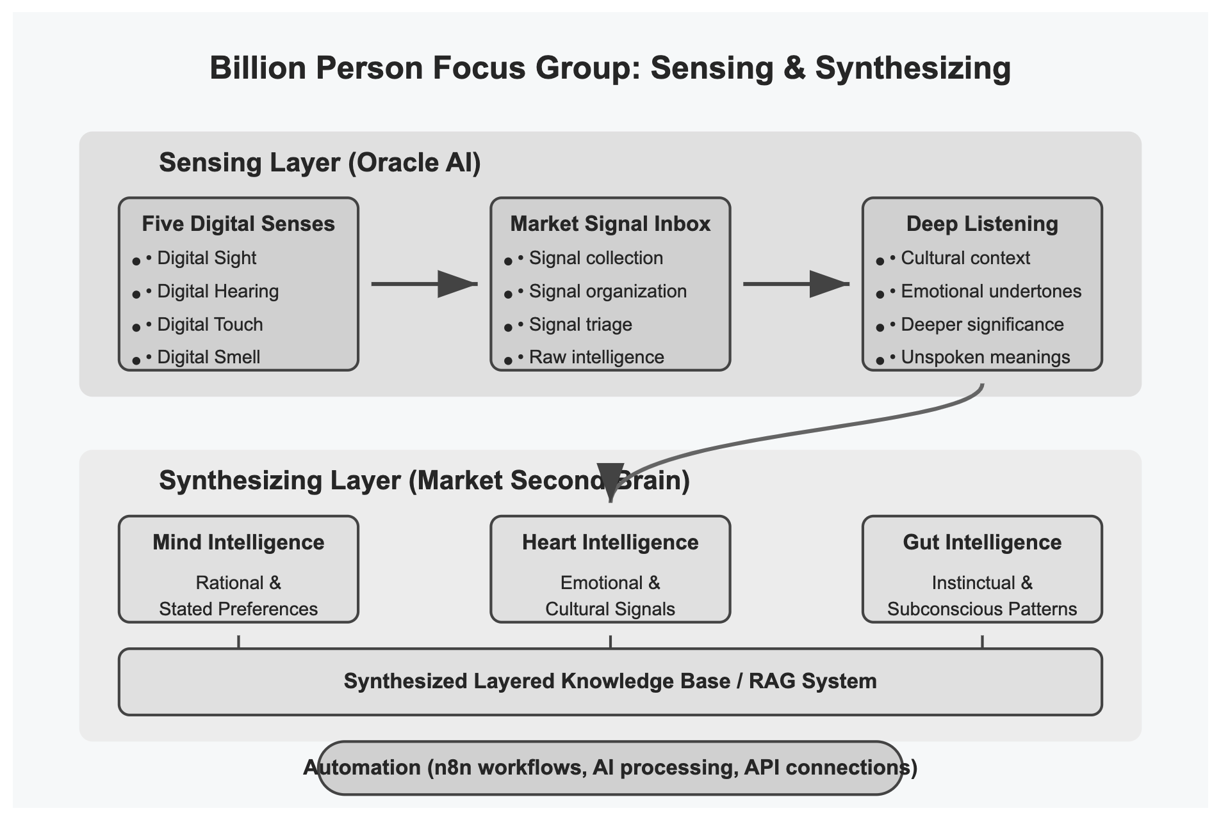

## **Moving from Collection to Connection**

The key difference between your Signal Inbox and Second Brain is purpose:

**Signal Inbox = COLLECTION**

* Individual, isolated signals
* Raw, unprocessed information
* Maximum breadth and volume
* Original context preservation

**Second Brain = CONNECTION**

* Relationships between signals
* Processed, analyzed insights
* Focus on quality and meaning
* New context through connection

You need both working together—your Second Brain builds on your Signal Inbox, not replaces it.

## **Setting Up Your Second Brain Structure**

Your Market Second Brain requires a specific structure to support pattern recognition and insight generation. Let's build this framework:

### **The Three Core Tables/Databases**

1. **Processed Signals**
   * Your analyzed and enhanced signals
   * Connected to patterns and insights
   * Enriched with deeper analysis
2. **Patterns & Themes**
   * Emerging connections between multiple signals
   * Mid-level insights showing what's happening
   * Developing hypotheses about market trends
3. **Strategic Insights**
   * Fully-formed insights driving action
   * Connected to multiple patterns
   * Linked to your business strategies

## **Mind, Heart, and Gut Intelligence Layers**

Each signal, pattern, and insight in your Second Brain should include analysis across three intelligence dimensions:

### **Mind Intelligence (Rational/Analytical)**

* What people say they want
* Logical reasoning and explicit needs
* Stated preferences and requirements

### **Heart Intelligence (Emotional/Cultural)**

* How people feel about experiences
* Values and identity expression
* Cultural context and meaning

### **Gut Intelligence (Behavioral/Instinctual)**

* What people actually do (vs. what they say)
* Unconscious patterns and behaviors
* Contradictions and workarounds

Here is an example of a post analyzed through all three intelligence lenses, showing the different insights each provides

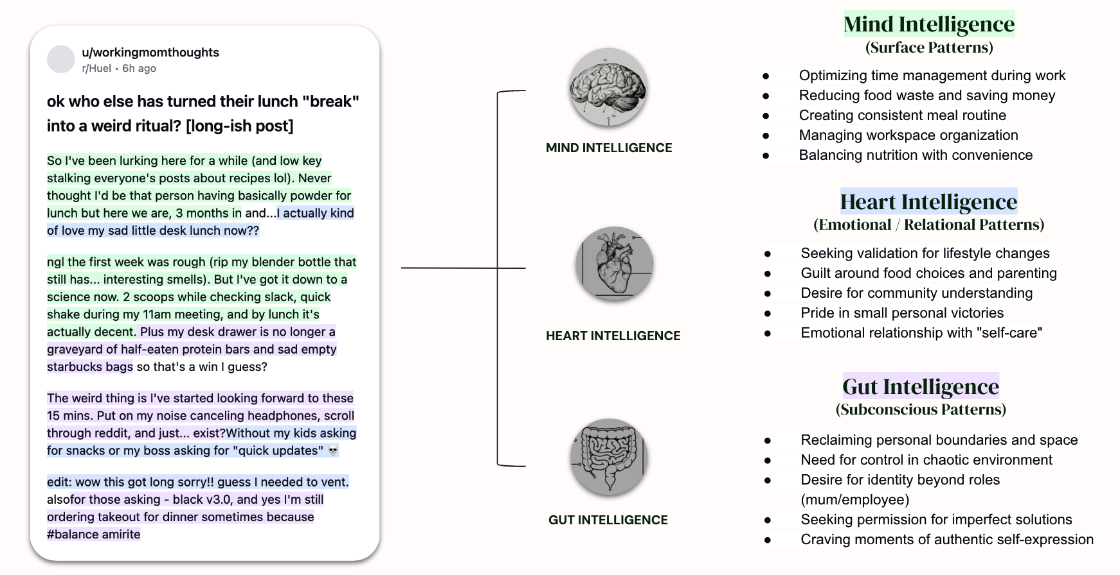

### **Megaprompt: Mind-Heart-Gut Insight Decoder**

Here’s a prompt you can apply to every new record or page entering your Second Brain

| You are an expert cultural analyst, emotional intelligence researcher, and behavioural semiotician. Given a personal post (like one from Reddit, Twitter, TikTok captions, or a transcript from a customer story), your job is to decode it through three levels of human intelligence:   1. Mind Intelligence (Surface Patterns): What logical, cognitive, or practical patterns can be observed? These include efficiency, routine, productivity, budgeting, planning, organisation, or nutrition. 2. Heart Intelligence (Emotional / Relational Patterns): What emotions, relational needs, or identity tensions are being expressed or hinted at? This may include pride, guilt, vulnerability, longing for connection, the desire to be seen or validated, or moments of joy, shame, or self-care. 3. Gut Intelligence (Subconscious Patterns): What deeper, instinctive, often unspoken motivations or tensions are bubbling underneath? Look for clues about autonomy, control, sensory craving, identity outside of roles, boundary-making, rebellion, or existential release. These are the shadow or instinctive signals.   Now take the following post and decode it into those 3 types of intelligence. Present each intelligence layer with a brief label for the key insight themes, followed by short bullet points for each sub-theme:  Post:  *[Insert full user post here, including all punctuation and emojis. Do not clean or summarise it beforehand.]*  Your output should look like this:  Mind Intelligence  *(Surface Patterns)*   * Theme 1: [e.g. Optimising workflow and meal prep]    + [bullet 1]   + [bullet 2]   Heart Intelligence  *(Emotional / Relational Patterns)*   * Theme 1: [e.g. Emotional attachment to new habits]    + [bullet 1]   + [bullet 2]   Gut Intelligence  *(Subconscious Patterns)*   * Theme 1: [e.g. Seeking autonomy in a chaotic environment]    + [bullet 1]   + [bullet 2] |
| --- |
|  |

## **Hands-on Setup Instructions for Airtable or Notion**

Now, let's build your Second Brain in either Airtable or Notion:



### **Option 1: Setting Up in Airtable (paste below into AI Co-Builder)**

1. **Create the Processed Signals Table**
   * Start with a new table in your Market Intelligence base
   * Name it "Processed Signals"
   * Set up these core fields:
     + Signal Title (Primary Field)
     + Original Signal (Link to Signal Inbox)
     + Date Processed (Date)
     + Significance (Number, 1-5)
     + Mind Intelligence (Long Text)
     + Heart Intelligence (Long Text)
     + Gut Intelligence (Long Text)
     + Related Patterns (Link to Patterns Table)
     + Key Tags (Multiple Select)
     + Processing Notes (Long Text)
2. **Create the Patterns & Themes Table**
   * Create another table named "Patterns & Themes"
   * Set up these core fields:
     + Pattern Name (Primary Field)
     + Pattern Description (Long Text)
     + Pattern Status (Single Select: Emerging, Growing, Established, Declining)
     + Supporting Signals (Link to Processed Signals)
     + Mind Layer Analysis (Long Text)
     + Heart Layer Analysis (Long Text)
     + Gut Layer Analysis (Long Text)
     + Pattern Strength (Number, 1-5)
     + Pattern Tags (Multiple Select)
     + Related Patterns (Link to self)
     + Pattern Notes (Long Text)
3. **Create the Strategic Insights Table**
   * Create a third table named "Strategic Insights"
   * Set up these core fields:
     + Insight Title (Primary Field)
     + Insight Description (Long Text)
     + Supporting Patterns (Link to Patterns)
     + Business Impact (Single Select: Low, Medium, High, Critical)
     + Action Implication (Long Text)
     + Confidence Level (Number, 1-5)
     + Insight Owner (Single Select)
     + Insight Status (Single Select)
     + Strategic Tags (Multiple Select)
     + Insight Notes (Long Text)
4. **Create Custom Views**
   * For each table, create views that help you see the data in useful ways
   * Examples: By Status, By Strength, High Priority, Recent Entries

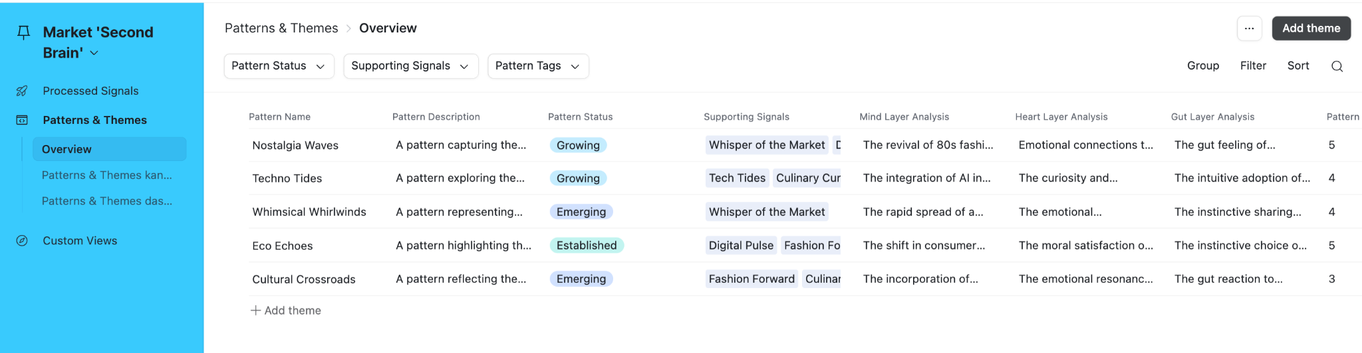



### **Option 2: Setting Up in Notion**

1. **Create the Processed Signals Database**
   * Create a new page titled "Market Second Brain"
   * Add a new database (full page) called "Processed Signals"
   * Configure properties similar to Airtable fields above
   * Add relation properties to connect to other databases
2. **Create the Patterns & Themes Database**
   * Add another database called "Patterns & Themes"
   * Configure properties as described in the Airtable section
   * Create relation properties to link to Signals and Insights
3. **Create the Strategic Insights Database**
   * Add a third database called "Strategic Insights"
   * Configure properties as described above
   * Create relation properties to link to Patterns
4. **Create Dashboard Views**
   * Create a dashboard page linking to all three databases
   * Add linked views showing recent items, high priority items, etc.

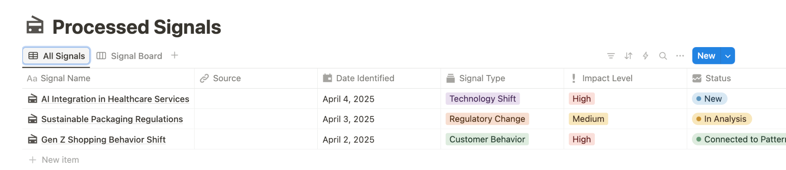

## **Creating a Tagging System**

A consistent tagging system is essential for connecting elements in your Second Brain:

### **Four Types of Tags to Include:**

1. **Descriptive Tags**: What the content is about
   * Examples: Product features, customer segments, competitors
2. **Interpretive Tags**: How you're making sense of the information
   * Examples: Emerging trends, behavioral patterns, emotional themes
3. **Strategic Tags**: How this connects to business decisions
   * Examples: Product roadmap, marketing strategy, customer experience
4. **Meta Tags**: Information about the information itself
   * Examples: Confidence level, evidence strength, signal recency

## **Working With Your Second Brain: Weekly Process**

To get the most from your Second Brain, establish this weekly workflow:

1. **Signal Processing** (15-30 minutes)
   * Review new signals in your Signal Inbox
   * Select significant signals for deeper processing
   * Move them to Processed Signals with multi-intelligence analysis
2. **Pattern Recognition** (30-45 minutes)
   * Review recently processed signals for connections
   * Update existing patterns with new supporting signals
   * Create new patterns when sufficient signals exist
3. **Insight Development** (30-45 minutes)
   * Review patterns for strategic implications
   * Update existing insights based on pattern evolution
   * Create new strategic insights when patterns suggest action

## **Integration with Automation**

Your Second Brain becomes even more powerful when connected to automation:

* Use n8n or Zapier to automate the flow between Signal Inbox and Second Brain
* Set up AI processing to help with multi-intelligence analysis
* Create automated pattern detection workflows
* Build notification systems for high-importance insights

Details on these automation options are covered in the automation lesson handout, but keep them in mind as you design your Second Brain structure.

## **Next Steps**

Now that you've set up your Market Second Brain:

1. **Start Processing**: Move 5-10 high-value signals from your Signal Inbox
2. **Create Initial Patterns**: Identify 2-3 patterns based on these signals
3. **Establish Your Workflow**: Schedule your weekly processing session
4. **Refine Your System**: Adjust the structure based on your specific needs

Your Second Brain will evolve as you use it, becoming more valuable with each new signal and connection you make.

Remember: The goal isn't perfect organization—it's creating a system where patterns can emerge and insights can develop. Focus on connection rather than collection, and you'll build a powerful intelligence asset for your business.